**Working Game Title**

*Your Name and email address*

***The Introduction and/or Marketing tagline goes here. This   
is the catchy line or two that attracts attention   
and really makes the reader want to find out more!***

**Genre:***Perhaps a genre?*

**Platform:** *PC, iOS, Wii, Xbox…*

**Description:** Describe the game to the reader as if they are the player.  
Do this from the second-person perspective (you). This description  
should be very exciting and thrilling. You will find it can then be  
a mesmerizing and imagination capturing storyline for your game. It should tell of grand adventure and daring deeds. Detailing how you will experience all the adrenaline and spine tingling sensations that   
can be imagined as you explore and do great and magnificent things. It might start with words like: *It was a dark and stormy night, you were out by the… when… You now find yourself…* This description should be a single paragraph.

**Key Game Features**

* Create a list: List the unique and interesting aspects of your game
* Sell your game: Be descriptive. Look at as many examples as you can
* Keep it brief: Keep the list around 5 points, never more than 10
* Use visual enhancements: Images may complement these bullet points nicely
* Define your game: These points are the what, how, and why your game should be made
* Summarize your items: Each bullet might be a topic word or two, followed by a description

**Gameplay:** Beyond the above there should be a paragraph or a diagram or both or something more to give the feel of how the game will actually play. Typically this is addressed in a description or outline of game mechanics, user interfaces, and descriptions or presentation of game images, videos, sounds, and music. Sometimes it will include a comparison to existing games to convey such ideas, be sure to identify how your game is different though. Also make mention of networking and multi-player abilities if needed.



You have 1 to 2 pages to sell your game. The above is minimal. Organize the information well. *The above is only ONE way to organize things*. Rearrange things. Use more images. Highlight differently. Apply different fonts. You can use document layout, font selection, and other subtle details to imply additional aspects of your game. You do NOT have to use two pages, sometimes one is enough.

On the next page several additional topics are presented. You should carefully select if you will mention any, all, or none of them in your document and how detailed you want to be. Focus on things that will SELL YOUR GAME IDEA. Be certain you are conveying the LOOK and FEEL of the game. Know your audience. Guide them to the desired conclusion of how great your game is.

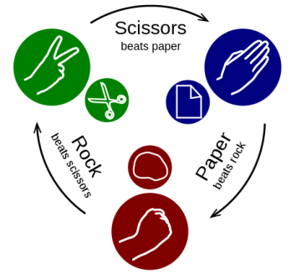**Game Mechanics: Core Gameplay and Game Flow**

In a paragraph or less describe the essence of the game. These will be words from which the design grows. This is a more technical (non-narrative) description. Game flow may be illustrated with a diagram or words or both. Trace the flow of gameplay with a description of player activity. Focus on the progression of challenges and entertainment. Be specific about what the player does. Do not describe the GUI. Describe what the player can and will typically do. The game flow activity should be an extension from the core gameplay.

Having an explicit description of the game’s rules is also valuable: What can the player do? What is the nature of the game’s environment? What does it do?

Important parts of Game Mechanics include:

**Points/Scoring 🡨 This really should be addressed in every Inception Document**

What are the players trying to accomplish? How will they know they succeeded?

Is it score based? How is the player scored? What achievements do players get as they play?

**Endgame 🡨 This too should be addressed in every Inception Document**

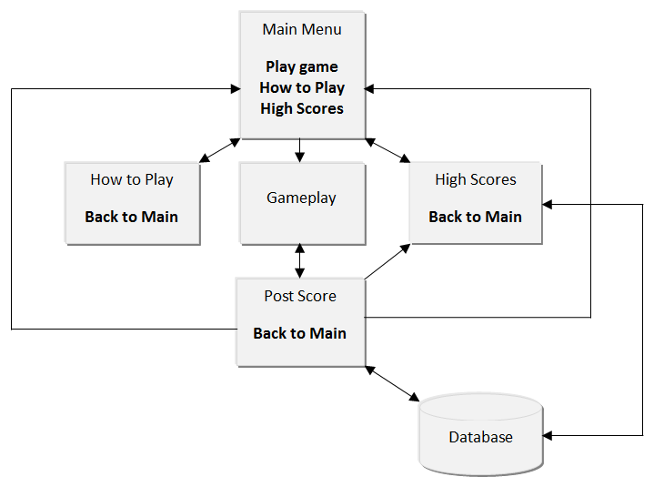How does the game end? How does the player win? How does the player lose? Can the game be played again? Why would it be played a second time?

**User Interface**

You may provide a flowchart to demonstrate how the player will navigate through various screens. You may use mock-up sketches to illustrate your main gameplay screen and the information it will convey to the player.

**Art and Sound**

Art style can be described in words or implied by included artwork. The use of sound in your game will require words (voice acting, sound effects, music). If sound is going to be a major component of your game then describe how it will be. Discussion of cut scenes, or other video playback within the game, may also be useful.

**Story**

A synopsis of your game’s story is good to have. This is implied greatly from the above descriptions. Additional details may be explicitly mentioned – briefly. Leave room for adaptation. Story provides context for how the player got to where the game starts and how they will win or lose or forever play the game.

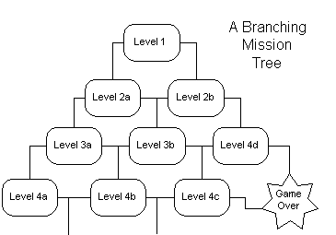**Levels**

What are levels in your game? How does the player go through them? Is a specific order required? What, if any, level defines the “end?” How does the player get there?

**Meta-Purpose 🡨 May offer new context to re-task or reuse old/proven game setup**

Does the game have educational or training aspects to it? Does the game test a new interface? Does the game trick players into accomplishing something that is beyond the explicit game?

**Schedule, Personnel, Tools, and Asset Requirements**

What is needed to make this game? How long will it take? How much will it cost? Will support tools need to be created (e.g. level design tool)? How many people (of what skillsets) will this require?